36.29: a) 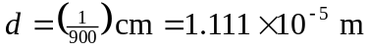
For 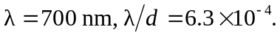 The first-order lines are located at 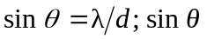is small enough for 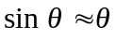 to be an excellent approximation.
b) 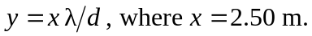
The distance on the screen between 1st order bright bands for two different wavelengths is 